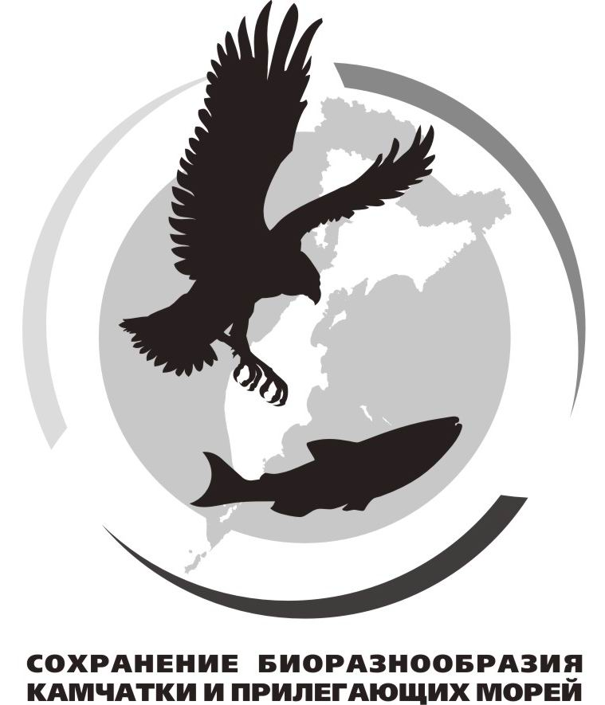
Information Bulletin № 1

Dear colleagues!

We invite you to participate in the ХX International Scientific Conference "Conservation of Biodiversity of Kamchatka and Coastal Waters", dedicated to the 150th birthday anniversary of the outstanding scientist, head of the Botanical Department of the Kamchatka expedition of the Russian geographical society, curb the means of F. P. Ryabushinsky, academician V. L. Komarov. The conference will be held on November, 12-13, 2019, in the Petropavlosk-Kamchatsky city.

Vladimir Leontievich Komarov (1869-1945) – an outstanding Russian botanist, geographer and traveler, academician, President of the USSR Academy of Sciences, honorary President of the Geographical society of the USSR, who made a huge contribution to the study of the far East flora. In 1895, after graduating from St. Petersburg University, in connection with the proposed construction of the Amur railway, V. L. Komarov was invited for soil and Botanical research of the Amur region. Later, at the suggestion of The Russian geographical society, he explored Manchuria (1896) and the Northern part of Korea (1897). For travel in 1896-1897. The Russian geographical society awarded the V. L. Komarov medal named after N. M. Przhevalsky, and his three-volume work "flora of Manchuria" was awarded in 1909 by the St. Petersburg Academy of Sciences award in the name of K. M. Baer.
In 1908-1909, V. L. Komarov supervised the work of the Botanical Department of the RGS expedition, equipped with the funds of p. L. Ryabushinsky, during which he collected a large collection of plants. The result of this expedition was a three-volume work "flora of the Kamchatka Peninsula", containing a description of 825 species of plants, including 74, first described by V. L. Komarov. The scientist proved himself as an outstanding naturalist with diverse scientific interests: in addition to a detailed study of the flora of the Peninsula, he described the population of Kamchatka, its life, occupations; he studied the Geology of the surveyed areas and collected material for their geographical description.

Conference organizers: Kamchatka Branch of the Pacific Geographical Institute (KB PGI) FEB RAS, Kamchatka regional branch of the Russian geographical society (RGS), Kamchatka regional scientific library named after S. P. Krasheninnikov, Kamchatka branch of the Russian Botanical society.

Conference objective - analysis of the current status, level of knowledge and problems of the biodiversity conservation in the Kamchatka Peninsula and the surrounding marine areas in the conditions of increasing anthropogenic influence; principles, problems and perspectives of the special protection nature areas functioning. The official language of the conference is Russian. For reports presented in English simultaneous translation will be provided.

Organizing committee:
Chairman: Tokranov A.M., Doctor of Biology (KB PGI FER RAS).
Organizing committee members: V. F. Bugaev, Ph.D. (Kamchatka branch of VNIRO - KamchatNIRO), Nechaeva O. P. (Krasheninnikov Regional Scientific Library), Devyatova, E. A., Ph.D. (Vitus Bering Kamchatka State University), Lobkov E. G., Ph.D. (Kamchatka State Technical University).
Senior secretary: senior secretary of KB PGI FER RAS Chernyagina O.A.

During the conference the following main themes will be traditionally observed:

1. Current status of Kamchatka biodiversity and the history of its study.
2. Theoretical and methodological aspects of the biodiversity protection.
3. Problems of the Kamchatka biodiversity protection under the increasing anthropogenic impact.
4. Specifics of protection of biodiversity of Kamchatka marine coastal ecosystems.
5. Research and monitoring in specially protected natural areas.
6. Ecological and educational activities in the Kamchatka territory.
9. Status of the species included in the Red Data Book in Kamchatka and the adjacent regions.
10. Problems of biodiversity conservation in the adjacent to Kamchatka territories and water areas.

Three levels for presenting abstracts are provided: session talks, posters and distant presentation which means publication of the abstract in conference proceedings and on website. Optionally poster presentations can be accompanied by a short (up to five minutes) talk. Abstracts submitted to the conference will be published in the conference proceedings and placed on the website of the Kamchatka Branch of the Pacific Geographical Institute of FEB RAS (www.terrakamchatka.ru). On this site you can also find the materials from the previous thirteen conferences. The conference proceedings are also transferred to the Scientific Electronic Library (www.elibrary.ru) for inclusion in the itemized system of the Russian index of scientific citation (RISC). By submitting the publication materials, you agree to be placed in the RSCI.

Guidelines for abstracts.
Abstracts should be up to 3 pages in length (tables and figures may be included) and should be submitted to the conference organizing committee in printed (entered in Word, Times New Roman font, 12 pt font size, single line spacing, A4 paper size) and electronic versions (format RTF, file should contain the name of the first author, graphic material should be placed in text of abstracts and also, obligatory, sent as separate files saved in tiff, jpg or xls formats). Abstracts can also be sent by e-mail to the following address: kambiodivers-20@mail.ru. The conference organizing committee earnestly requests all the participants to keep to the established abstract size. Page sizes should be the following: the left margin should be 30 mm, the right margin - 15 mm, the top and bottom margins - 25 mm. Paragraph indent should be equal to five spaces. First in the middle of the page should come an abstract title printed in upper case in Russian and in next line – in lower case in English. The initials and last name of the author (or authors) should be written one space below, with the next line containing the author’s affiliation (first in Russian and then in English). The text of the abstract should come one line below and obligatory followed by a list of references (advisably not more than 5-6 references) at one spacing. One can submit no more than two abstracts as a first author and no more than three abstracts as a co-author.
Foreign authors can make their presentations in either English or Russian. English language abstracts will be translated into Russian and published in both languages.

The applicants should provide the following information: the abstract title, preferred format of presentation (talk, poster or publication in proceedings and online), author's full name, affiliation, official address, telephone and fax and, if available, an e-mail address for correspondence.

Applications forms for participating in the conference and abstracts should be submitted to the following address by September 2, 2019 by e-mail: kambiodivers-20@mail.ru.

Example of abstract presentation

ABSTRACT TITLE
(First in Russian, then in next line in English)

I. I. Ivanov*, P. P. Petrov**

I. I. Ivanov*, P. P. Petrov**
*Kamchatka Branch of the Pacific Geographical Institute FEB RAS, Petropavlovsk-Kamchatsky
**Soil and Biology Institute, FEB RAS, Vladivostok
(First in Russian, below in English)

Abstract.
References
Kazantsev, S. V. New Taxonomy of Soft Shell Beetles // Journal of Zoology. Volume 80, Issue 9. pp. 1076-1083.

The organizing committee retains the right to edit and decline the submitted abstracts using its own discretion. Articles longer than three pages may be abridged.
Information on the conference agenda and program will be sent to participants after November 4, 2019.

Organizing committee

ХX International Scientific Conference “Conservitin of Biodiversity of Kamchatka and Coastal Waters” dedicated to the 150th birthday anniversary of the outstanding scientist, head of the Botanical Department of the Kamchatka expedition of the Russian geographical society, curb the means of F. P. Ryabushinsky, academician V. L. Komarov.

APPLICATION FORM
November 12-13, 2019
Petropavlovsk-Kamchatsky

Last name:
First name:
Country:
Affiliation:
Position, degree:
Official address:
Telephone (country and city codes):
Fax:
E-mail:
Title:
Type of presentation: | Talk / Poster / Publication only (underline the correct)
Authors:
Presenting author:

